Internet Portal Mintenance and Operation project for NBU

**Required content document for administrations and agencies subsites**

*Sent to:*

**

This Document has been prepared by:



الشركة الإلكترونية للتكنولوجيا العالية المحدودة

Sent Date:

27Feb, 2020

**Table of Contents**

1 Important Links……………………….. 3

2 About Agency/Administration…………… 4

3 Agency / Administration Photo…………. 5

4 Dean’s Speech…………………………. 6

5 Administrations and Departments…….. 6

6 Events…………………………………… 6

7 Directory……………………………….. 7

8 Photo Gallery………………………….. 7

9 Advertisements………………………… 8

10 News……………………………………. 8

|  |  |
| --- | --- |
| Status | College Contents |
|  | Important Links |
|  | About Agency/Administration |
|  | Main Photo for Agency/Administration |
|  | Dean’s Speech / Dean’s Photo |
|  | Administrations and Departments |
|  | Events and Activities |
|  | Directory |
|  | Photo Gallery |
|  | Advertisements |
|  | News |

1. Important Links



Please add a list of the most important links for the college:

|  |  |
| --- | --- |
| Link | Link Name |
|  |  |

Each agency or administration page will contain the following lists. At least in the right menu:

1. About Agency/Administration

The about agency / administration page will contain an introductory text of agency or administration, page will also contain an expressive image of agency/ administration, the suggested text may contains: about, vision, message, and values, The suggested text is preferred not to take more than one page, an image express the agency or administration will be chosen by staff team. Below is an example of image for public administration.

1. Agency / Administration Photo

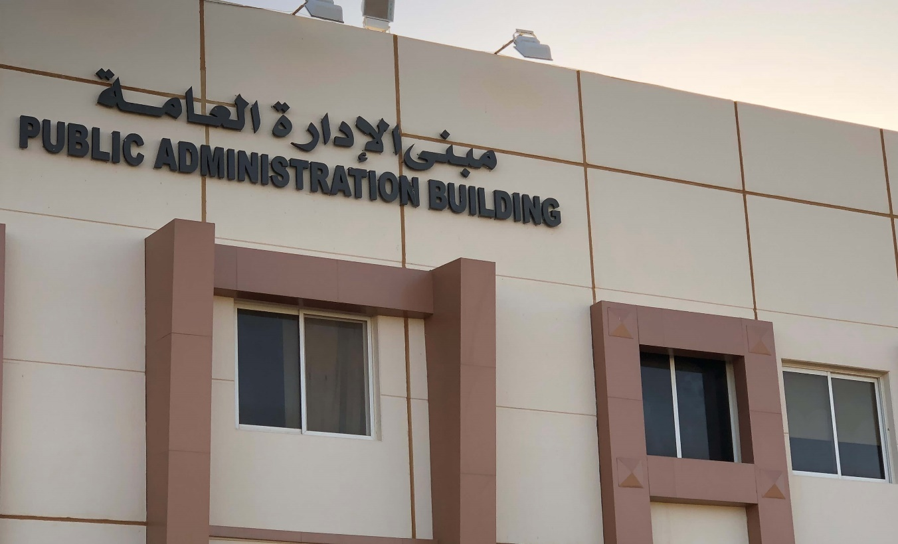

Please include the introductory text of agency or administration.

Please attach the agency / administration photo in the following specifications:

Size: (840 * 1475) Length * Width

The photo is preferred to contain the name of agency or administration and to be taken professionally that fit to put it in the site.

|  |  |
| --- | --- |
|  | IT team member can be used to select the appropriate image. |

1. Dean’s Speech

This Page will contain the dean’s Speech, and it may also contain a personal photo of the dean or a photo of the administration / agency.

Dean’s Photo

Please attach the Dean’s photo.

1. Administrations and Departments

The list of administrations and departments will contain a sub-menu for administrations or agency departments, and when clicking on department or administration: there will be a brief description for each administration or department.

Please add administrations or departments next:

Please add a brief for each department or administration

1. Events

The events page will contain a list of the current and upcoming events like conferences and competitions. Where each event contains the following:

* Title
* Event description
* Event Date
* Event Time
* Event Location
* Photo

1. Directory

The directory page will contain a set of documents as pdf or doc files, where the page can be used to download the directories, procedures and any documents that the administration or agency site visitors can take advantage from it. Documents can be classified into more than one classification and the documents can be uploaded by clicking on the document name.

Please determine the attachments classifications.

Please attach the documents and directories for each classification.

1. Photo Gallery

Photo gallery page will contain a set of images that can be classified and navigated in it in easy way.

Please add photos classification:

Please attach photos for each classifications.

With the following specifications.

Size: (840 * 1475) Length * Width

1. Advertisements

The advertisements page will contain the latest advertisements pic for the agency or administration, and may add the advertisement with a short text and the link of the advertisement shows the latest advertisements in the main page automatically.

The advertisements pic will be requested if it’s found before the actual and trial launch of the site on time.

It can also be added any other tabs for the agencies or administrations in the right menu. And edit the current tabs and edit the order of it through a specific partial inside the portal management section.

1. News

The news page will contain the latest news pic for agency or administration. The news page will contain a list.

In which each news contains the following:

* Title
* News description
* News Date
* Photo
* News Content

Please attach photo for news.

In the following specifications:

Size: (840 * 1475) Length * Width