Internet Portal Mintenance and Operation project for NBU

**Required content document for colleges subsites**

*Sent to:*

**

This Document has been prepared by:



الشركة الإلكترونية للتكنولوجيا العالية المحدودة

Sent Date:

27Feb, 2020

**Table of Contents**

1 Important Links……………………….. 4

2 About College …………………………. 4

3 College Image ………………………….. 5

4 Dean’s Statement ……………………….. 6

5 Departments ……………………………… 6

6 Programs ……………………………….. 6

7 Events ………………………………….. 8

8 Directory ………………………………….. 8

9 Photo Gallery …………………………….. 9

10 Faculty Members ………………………… 9

11 Graduates ………………………………… 10

12 News …………………………………… 10

|  |  |
| --- | --- |
| Status | College Contents |
|  | Important Links |
|  | About College |
|  | College Image |
|  | Dean’s Speech |
|  | Departments |
|  | Programs |
|  | Events |
|  | Directory |
|  | Photo Gallery |
|  | Teaching Faculty Members |
|  | Graduates |
|  | News |

1. Important Links

Of Icons to choose from, here are some examples of some of the icons that will be used.



Please add a list of the most important links for the college:

|  |  |
| --- | --- |
| Link | Link Name |
|  |  |

1. About College

About College page will contain an introductory text about the college, and the page will also contain an expressive image of the college.

1. College Image

Please attach a picture of the college with the following specifications:

Size: (1475 * 840) Length * Width.

The photo is preferred to contain the name of college and to be taken professionally that fit to put it in the site.

|  |  |
| --- | --- |
|  | IT team member can be used to select the appropriate image. |

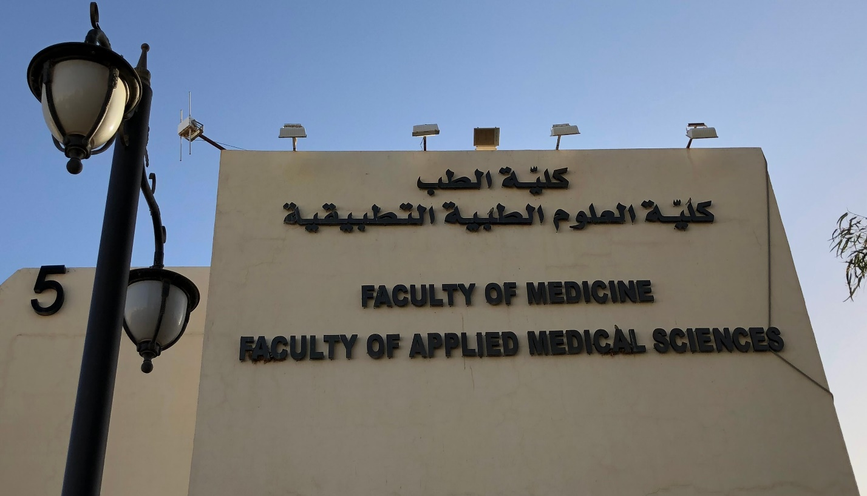

1. Dean’s Speech

This Page will contain the speech of the dean, and it may also contain a personal photo of the dean or a photo of the college.

Dean’s Photo

Please attach the Dean’s photo.

1. Departments

The departments list will contain a sub-menu list of college departments and when clicking on department: there will be a brief description for each department and when clicking on department will be navigated to the department's home page that contains:

* + About Department.
  + Department Courses.

Please add (About Department and Department Courses) for each department.

1. Programs

The programs page will contain a list of programs provided by the College, where it will contain an overview or introduction of these programs, and then there will be a table containing (the list of programs) where contains the following titles:

Program title, scientific degree and location (building name/college and place)

Please add program title, scientific degree and location for each program.

When clicking on any program will be navigated to the program’s home page that contains the following tabs:

1. Program Overview  
   It contains about program and the following info:

* College Name.
* Campus
* Path
* Academic Level.
* Scientific Degree.
* Student Category.
* Years of Studying.
* Credit Hours.
* Additional Requirements.

1. Study plan contains every year on:

* Course Number.
* Course Title.
* Credit Hours.
* Course Hours.
* Previous Requirements.

Please add program overview for each program.

1. Events

The events page will contain a list of the college's current and upcoming events, such as conferences and competitions.

Where each event contains the following:

* Title.
* Event Description.
* Event Date.
* Event Time.
* Event Location.
* Image.

Events will be requested before the actual and trial launch of the site on time.

1. Directory

The directory page will contain a set of documents as pdf or doc files, where the page can be used to download the directories, procedures and any documents that the college site visitors can take advantage from it. Documents can be classified into more than one classification and the documents can be uploaded by clicking on the document name.

Please determine the attachments classifications.

Please attach the documents and directories to the college for each classification.

1. Photo Gallery

Photo gallery page will contain a set of images that can be classified and navigated in it in easy way.

Please add photos classification:

Please attach photos for each classifications.

With the following specifications.

Size: (840 * 1475) Length * Width

1. Faculty Members

The faculty members’ page will contain a list of faculty members in the college. It also provides the ability to search for a faculty member by name, job and college.

Where the identification card for each faculty member contains:

* Name
* Job
* College
* Department
* E-mail

When the information of the faculty member display, three tabs will appear in addition to the previous information representing the qualifications of the faculty member, scientific research of the faculty member and the curriculum vitae of the faculty member.

Please attach a list of the faculty members in excel file format, where the information of each faculty member will be obtained by the competent systems.

1. Graduates

In this section a list of graduates will be shown ordered by the years where will be displayed:

* Graduate Name
* Major
* Graduation Date

Please add the list of graduates in excel file format.

It can also be added any other tabs for the college in the right menu. And edit the current tabs and edit the order of it through a specific partial inside the portal management section.

1. News

The news page will contain the latest news pic for agency or administration.

The news page will contain a list.

In which each news contains the following:

* Title
* News description
* News Date
* Photo
* New Content

Please attach photo for news.

In the following specifications:

Size: (840 * 1475) Length * Width